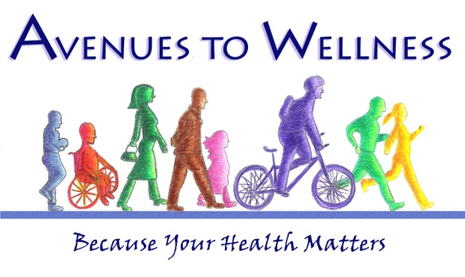

Volunteer Application

Please complete the following information:

First and Last Name:
Address:
City, State, Zip/Postal:
Email: Phone:
Have you attended any program(s) sponsored by Avenues to Wellness? If yes, which program(s)?
*You may also attach a resume in lieu of the following information Volunteer Experience:

Organization Name:
Dates of Volunteer Commitment: Hours per month:
Description of Volunteer Involvement:
Organization Name:
Dates of Volunteer Commitment: Hours per month:
Description of Volunteer Involvement:

What skills/experience do you have that you might be able to contribute to ATW?
(e.g. medical, computer, graphics, organization, public speaking, marketing, fundraising)

What do you hope to gain from volunteering with ATW? Are there particular areas of interest or skills you would like to acquire?

Please indicate your 1st, 2nd, and 3rd Volunteer preference:

_____ ATW Specials Program: Outreach and development of nutrition program with cafes
_____ Healthier Living Workshop: Ambassador to help promote ATW programs within the community
_____ Operations/Admin: Provider communication, data entry, graphic design, miscellaneous administrative duties
_____ ATW Speaker Series: Communication, marketing, preparation and class closeout
_____ Special Events: Volunteers will participate in community planning and preparation for special events
_____ Marketing/Outreach: Surveying clinicians/public, assist with preparation and distribution of literature and flyers, and ATW promotion

Please check the boxes that correspond to times that you are available to volunteer for the Center.

Day/time | Monday | Tuesday | Wednesday | Thursday | Friday
Morning
Afternoon
Late Afternoon

To the best of your knowledge, approximately how long do you intend to maintain your volunteer
role at Avenues to Wellness?
CERTIFICATION:
I certify that all of the statements made in this application are true, correct, and complete, to the best of my knowledge, and are made in good faith. I understand that misinformation or omission of information could result in disqualification and/or termination as a volunteer with the programs.
Applicant Signature Date

Additionally, please attach the following documents:
- Resume or Work History (optional, highly recommended)
- 1-2 References

Please send your application to ONE of the three options:

- E-mail: atwforhealth@gmail.com (Please put VOLUNTEER APPLICATION in subject line)

- Mail: Avenues to Wellness/Howard Foundation
3 Marcela Drive
Willits, CA 95490

3. Fax: (707) 459-2625

A completed application must have all required documents in order to be complete.

